Internet Programming
Lab Experiment 3
Aim
To develop an online bus ticket booking system that allows users to search buses, select seats, book/cancel tickets, and manage their bookings easily.
Algorithm
- Register and login to the system.
- Search for buses by route, date, and time.
- View available buses and seats.
- Select seats and enter passenger details.
- Make payment and confirm the ticket.
- Allow users to cancel bookings and post comments.
- Admin manages buses, users, schedules, and generates reports.
Program:
<!DOCTYPE html>
<html lang="en">
<head>
<meta charset="UTF-8">
<meta name="viewport" content="width=device-width, initial-scale=1.0">
<title>Online Bus Ticket Booking System</title>

<style>
body {
font-family: Arial, sans-serif;
background-color: #f2f6fc;
margin: 0;
}

header {
background-color: #174ea6;
color: white;
text-align: center;
padding: 20px;
}

nav {
background-color: #222;
padding: 12px;
text-align: center;
}

nav a {
color: white;
margin: 10px;
text-decoration: none;
}

section {
background: white;
margin: 20px auto;
padding: 20px;
max-width: 700px;
border-radius: 8px;
box-shadow: 0 0 5px #bbb;
}

h2 {
color: #174ea6;
}

input, select, textarea {
width: 95%;
padding: 10px;
margin: 8px 0;
}

button {
background-color: #174ea6;
color: white;
padding: 10px 18px;
border: none;
cursor: pointer;
border-radius: 4px;
}

button:hover {
background-color: #0b3275;
}

table {
width: 100%;
border-collapse: collapse;
}

th, td {
border: 1px solid #ccc;
padding: 10px;
text-align: center;
}

th {
background-color: #dce8ff;
}

footer {
background: #222;
color: white;
text-align: center;
padding: 15px;
}
</style>
</head>

<body>

<header>
<h1>Online Bus Ticket Booking System</h1>
<p>Book Your Journey Easily and Safely</p>
</header>

<nav>
<a href="#register">Registration</a>
<a href="#login">Login</a>
<a href="#search">Search Bus</a>
<a href="#booking">Book Ticket</a>
<a href="#cancel">Cancel</a>
<a href="#admin">Admin</a>
</nav>

<section id="register">
<h2>User Registration</h2>
<form onsubmit="registerUser(event)">
<input type="text" id="name"
placeholder="Enter Full Name" required>
<input type="email" id="email"
placeholder="Enter Email" required>
<input type="password" id="regpass"
placeholder="Create Password" required>
<button type="submit">Register</button>
</form>
</section>

<section id="login">
<h2>User Login</h2>
<form onsubmit="loginUser(event)">
<input type="email" id="loginemail"
placeholder="Enter Email" required>
<input type="password" id="loginpass"
placeholder="Enter Password" required>
<button type="submit">Login</button>
</form>
</section>

<section id="search">
<h2>Search Available Buses</h2>
<form onsubmit="searchBus(event)">
<input type="text" id="from"
placeholder="From Location" required>
<input type="text" id="to"
placeholder="To Location" required>
<input type="date" id="date" required>
<button type="submit">Search Bus</button>
</form>
<div id="busResults"></div>
</section>

<section id="booking">
<h2>Book Bus Ticket</h2>
<form onsubmit="bookTicket(event)">
<input type="text" id="passenger"
placeholder="Passenger Name" required>
<input type="number" id="age"
placeholder="Passenger Age" min="1" required>

<select id="category" required>
<option value="">Select Bus Category</option>
<option>Volvo AC</option>
<option>Sleeper Coach</option>
<option>Seater Coach</option>
</select>

<select id="seat" required>
<option value="">Select Seat</option>
<option value="A1">A1</option>
<option value="A2">A2</option>
<option value="A3">A3</option>
<option value="A4">A4</option>
</select>

<input type="text" id="route"
placeholder="Enter Bus Route" required>
<button type="submit">Confirm Booking</button>
</form>
<p id="bookingResult"></p>
</section>

<section id="cancel">
<h2>Cancel Ticket</h2>
<form onsubmit="cancelTicket(event)">
<input type="number" id="cancelId"
placeholder="Enter Booking ID" required>
<button type="submit">Cancel Ticket</button>
</form>
<p id="cancelResult"></p>
</section>

<section id="comments">
<h2>Comments and Feedback</h2>
<form onsubmit="addComment(event)">
<input type="text" id="commentName"
placeholder="Your Name" required>
<textarea id="commentText"
placeholder="Enter Your Comments"
required></textarea>
<button type="submit">Submit Comment</button>
</form>
<ul id="commentList"></ul>
</section>

<section id="admin">
<h2>Admin Panel</h2>
<p>Manage buses, categories, schedules and bookings.</p>

<form onsubmit="addBus(event)">
<input type="text" id="busName"
placeholder="Bus Name" required>
<input type="text" id="busRoute"
placeholder="Bus Route" required>

<select id="busType" required>
<option value="">Select Category</option>
<option>Volvo AC</option>
<option>Sleeper Coach</option>
<option>Seater Coach</option>
</select>

<input type="number" id="busSeats"
placeholder="Available Seats" min="1" required>
<button type="submit">Add Bus</button>
</form>

<h3>Bus Information</h3>
<table>
<thead>
<tr>
<th>Bus Name</th>
<th>Route</th>
<th>Category</th>
<th>Seats</th>
</tr>
</thead>
<tbody id="busTable"></tbody>
</table>

<h3>Booking Report</h3>
<button onclick="generateReport()">Generate Report</button>
<p id="report"></p>
</section>

<footer>
<p>&copy; 2026 Online Bus Ticket Booking System</p>
</footer>

<script>
let bookings = [];
let buses = [];
let bookingCount = 1000;

function registerUser(event) {
event.preventDefault();
alert("Registration completed successfully!");
event.target.reset();
}

function loginUser(event) {
event.preventDefault();
alert("Login form submitted successfully!");
event.target.reset();
}

function searchBus(event) {
event.preventDefault();

let from = document.getElementById("from").value;
let to = document.getElementById("to").value;
let date = document.getElementById("date").value;

document.getElementById("busResults").textContent =
"From: " + from + " | To: " + to +
" | Date: " + date +
". Select a bus from the admin bus list.";
}

function bookTicket(event) {
event.preventDefault();

let seat = document.getElementById("seat").value;

let alreadyBooked = bookings.some(function(booking) {
return booking.seat === seat &&
booking.status === "Confirmed";
});

if (alreadyBooked) {
document.getElementById("bookingResult").textContent =
"Seat already booked. Please select another seat.";
return;
}

let booking = {
id: ++bookingCount,
name: document.getElementById("passenger").value,
age: document.getElementById("age").value,
category: document.getElementById("category").value,
seat: seat,
route: document.getElementById("route").value,
status: "Confirmed"
};

bookings.push(booking);

document.getElementById("bookingResult").textContent =
"Ticket booked successfully! Booking ID: " + booking.id;

event.target.reset();
}

function cancelTicket(event) {
event.preventDefault();

let id = Number(document.getElementById("cancelId").value);

let booking = bookings.find(function(item) {
return item.id === id && item.status === "Confirmed";
});

if (booking) {
booking.status = "Cancelled";
document.getElementById("cancelResult").textContent =
"Booking " + id + " cancelled successfully.";
} else {
document.getElementById("cancelResult").textContent =
"Booking ID not found.";
}
}

function addComment(event) {
event.preventDefault();

let name = document.getElementById("commentName").value;
let comment = document.getElementById("commentText").value;

let li = document.createElement("li");
li.textContent = name + ": " + comment;

document.getElementById("commentList").appendChild(li);
event.target.reset();
}

function addBus(event) {
event.preventDefault();

let bus = {
name: document.getElementById("busName").value,
route: document.getElementById("busRoute").value,
type: document.getElementById("busType").value,
seats: document.getElementById("busSeats").value
};

buses.push(bus);

let row = document.createElement("tr");

[bus.name, bus.route, bus.type, bus.seats].forEach(function(value) {
let cell = document.createElement("td");
cell.textContent = value;
row.appendChild(cell);
});

document.getElementById("busTable").appendChild(row);

alert("Bus information added successfully!");
event.target.reset();
}

function generateReport() {
let confirmed = bookings.filter(function(booking) {
return booking.status === "Confirmed";
}).length;

let cancelled = bookings.filter(function(booking) {
return booking.status === "Cancelled";
}).length;

document.getElementById("report").textContent =
"Total Buses: " + buses.length +
" | Confirmed Bookings: " + confirmed +
" | Cancelled Bookings: " + cancelled;
}
</script>

</body>
</html>
Output:
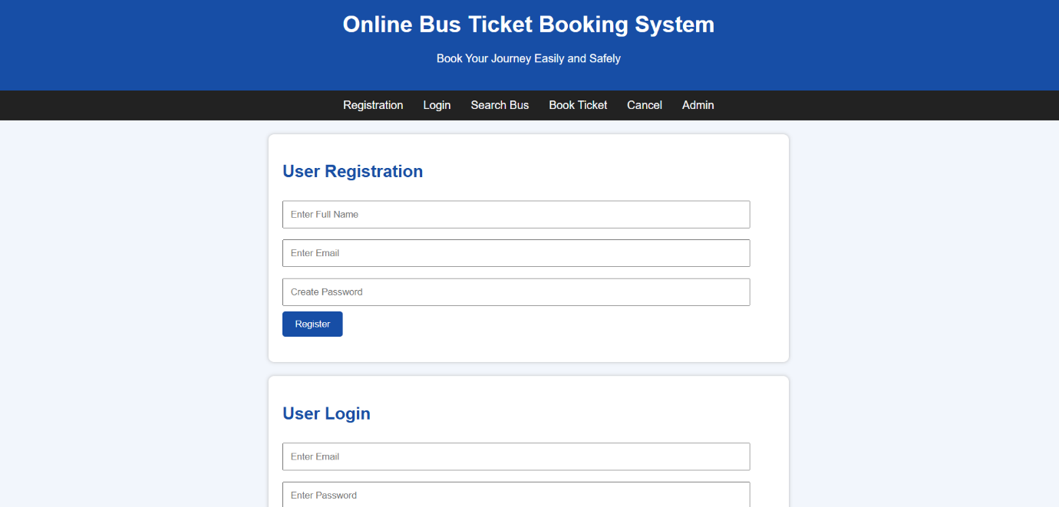
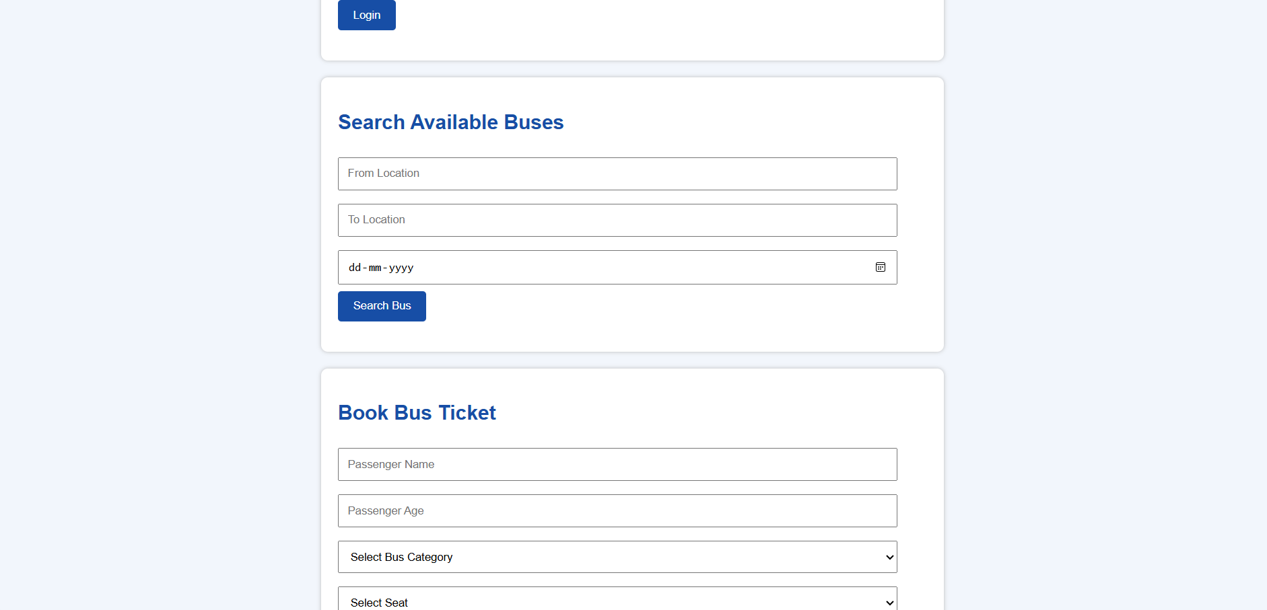
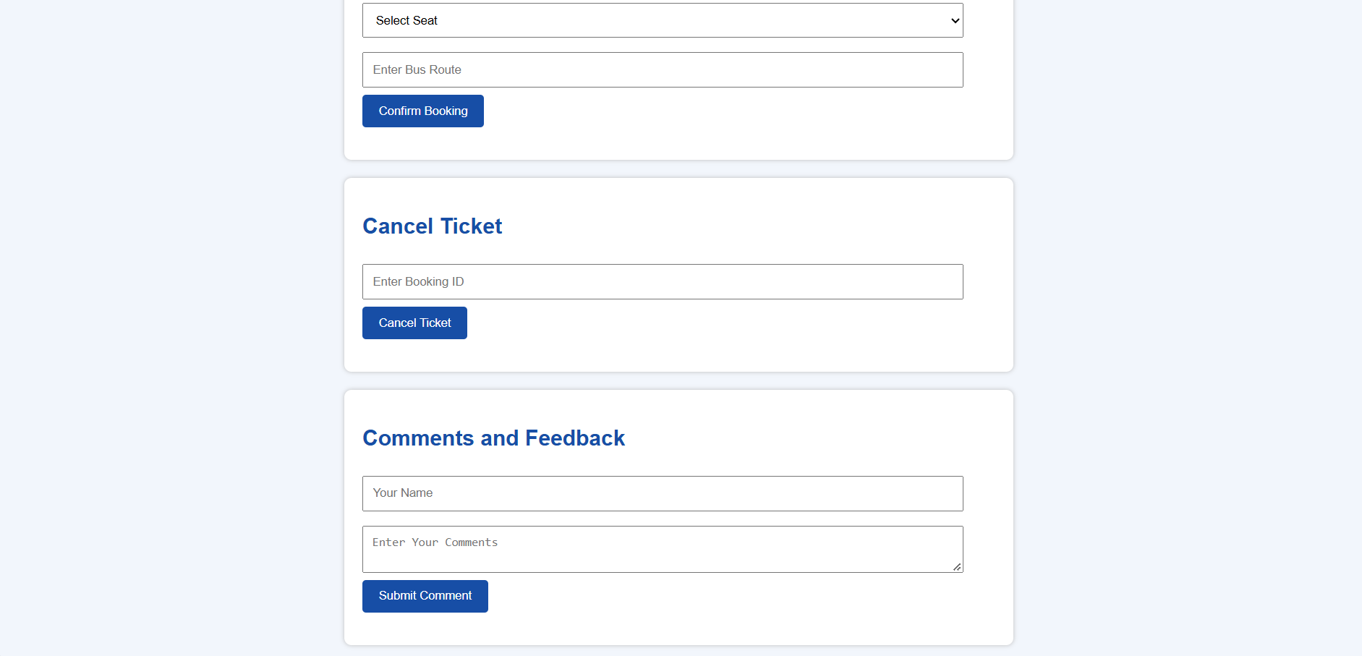
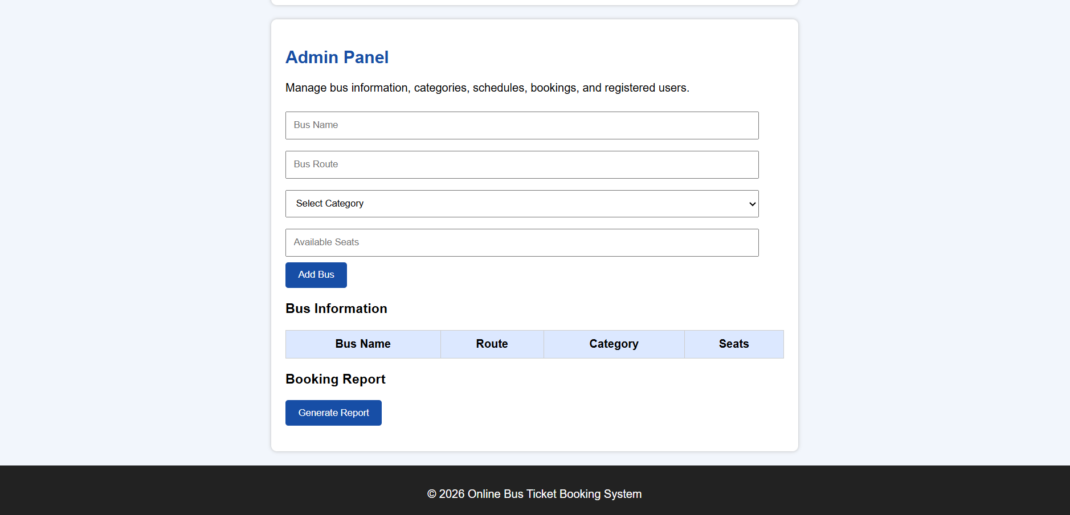
Result
The Online Bus Ticket Booking System was successfully developed. It provides a simple and convenient way for users to book and manage bus tickets, while allowing admins to efficiently manage the entire system.

